EXPERIMENT - 7

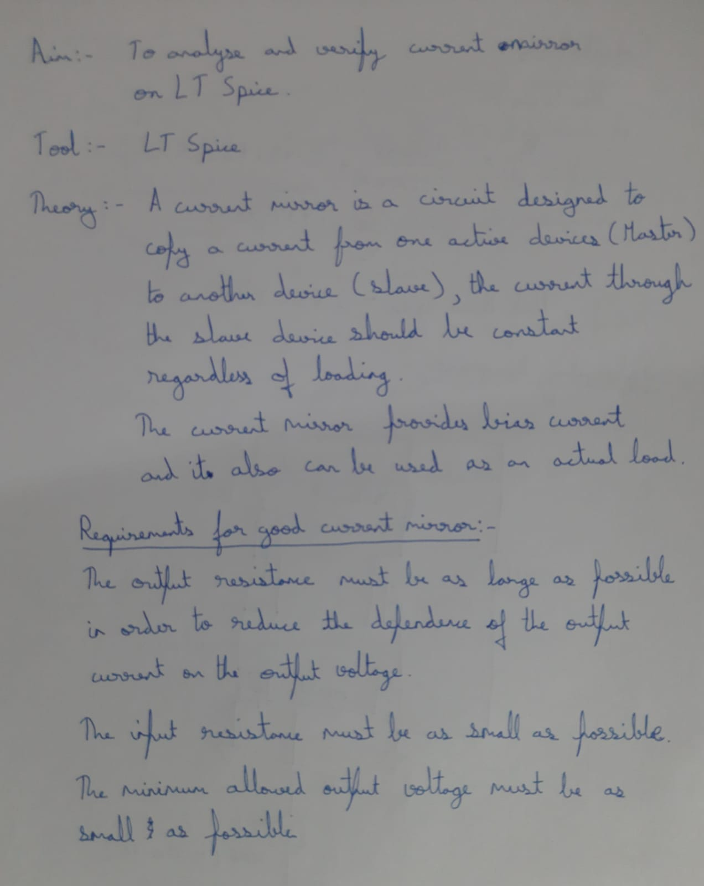

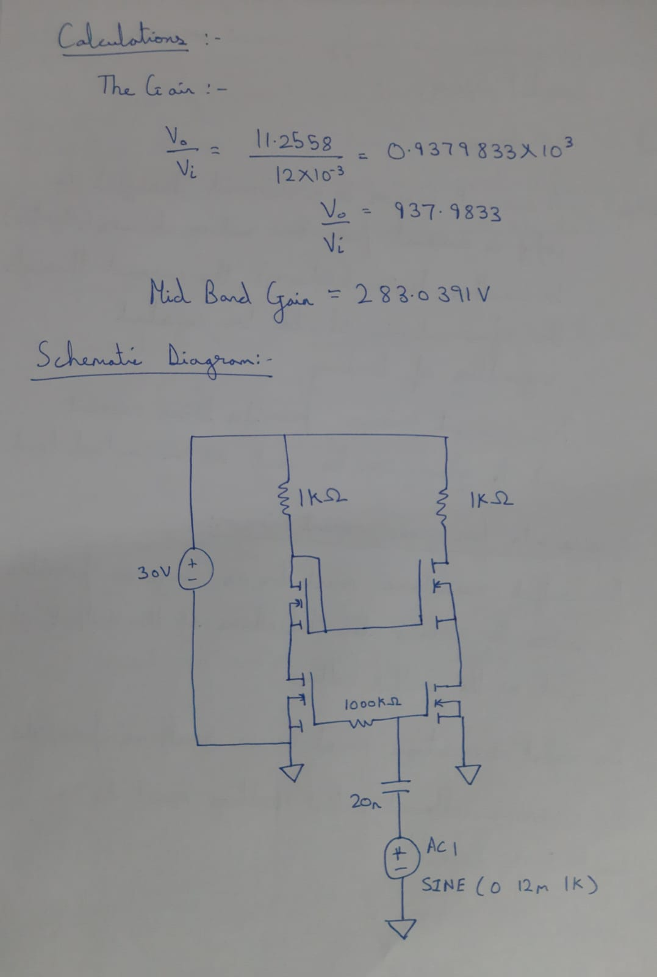

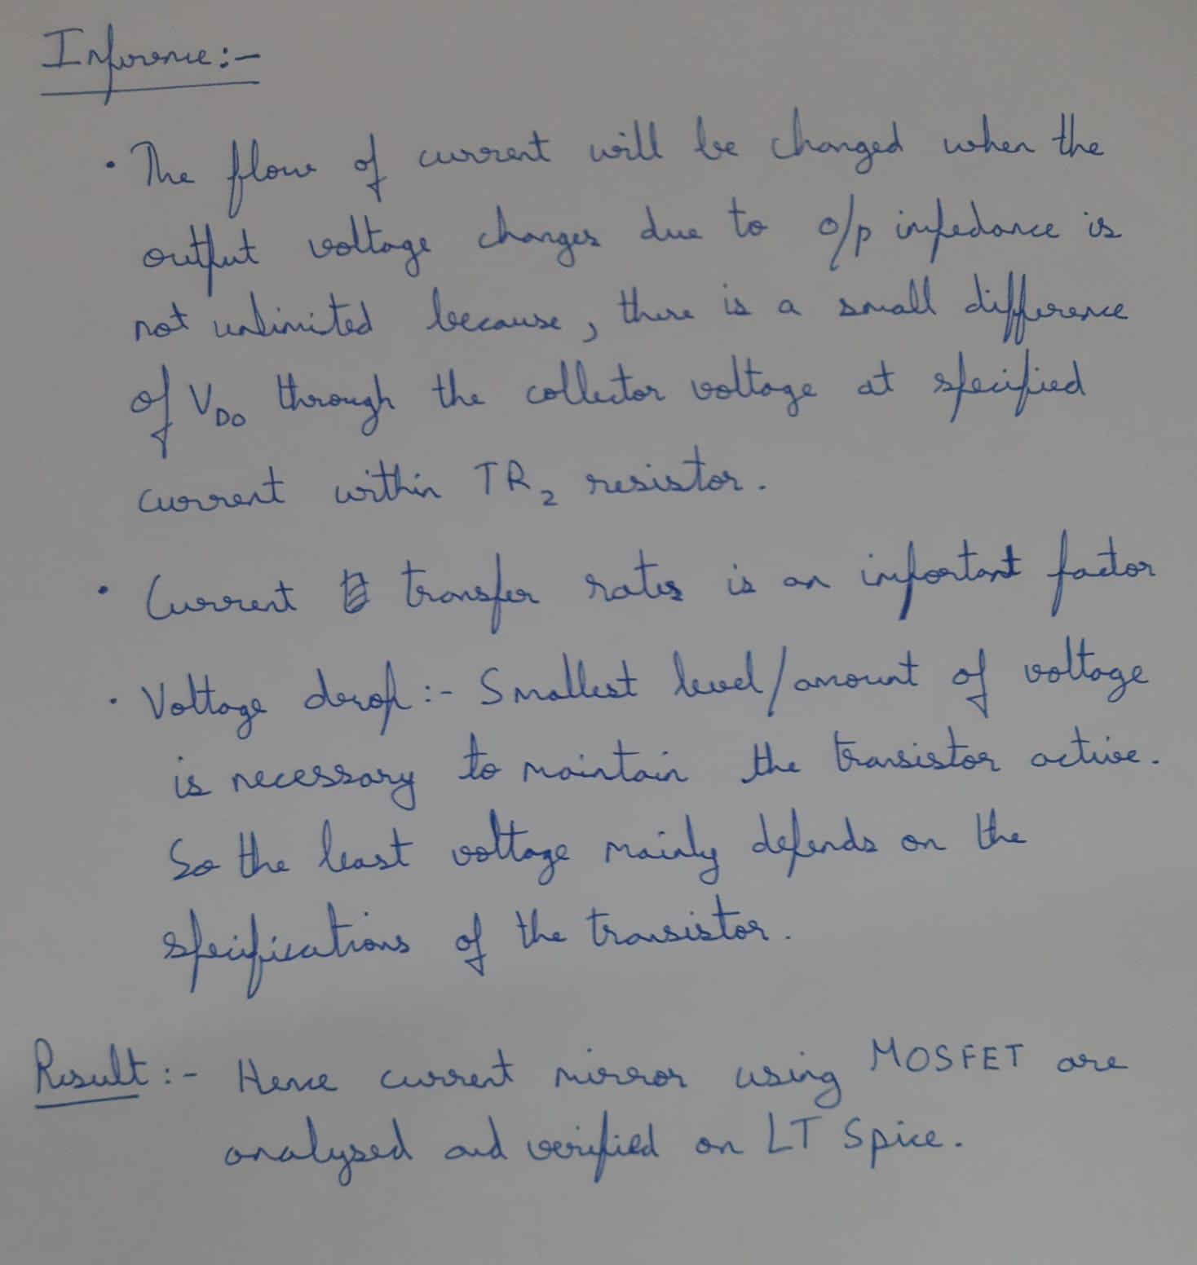

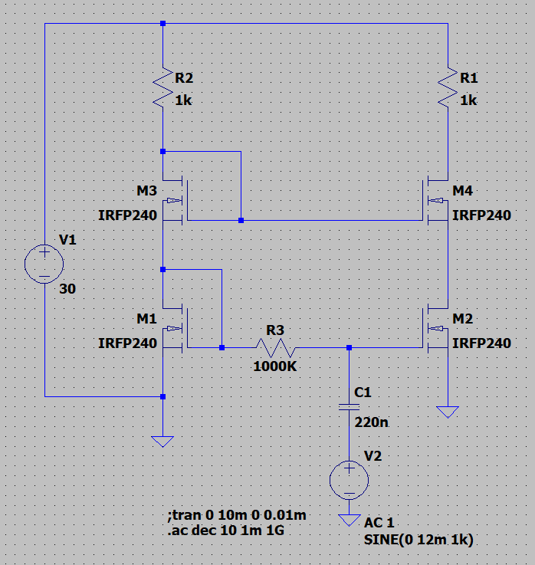

OUTPUT:

INPUT BELOW THE C1: -

OYPUT BELOW R1: -

